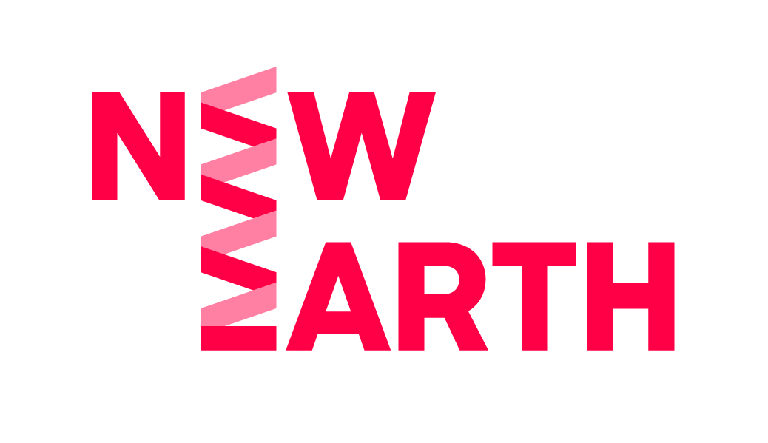

Theatre Maker Call Out
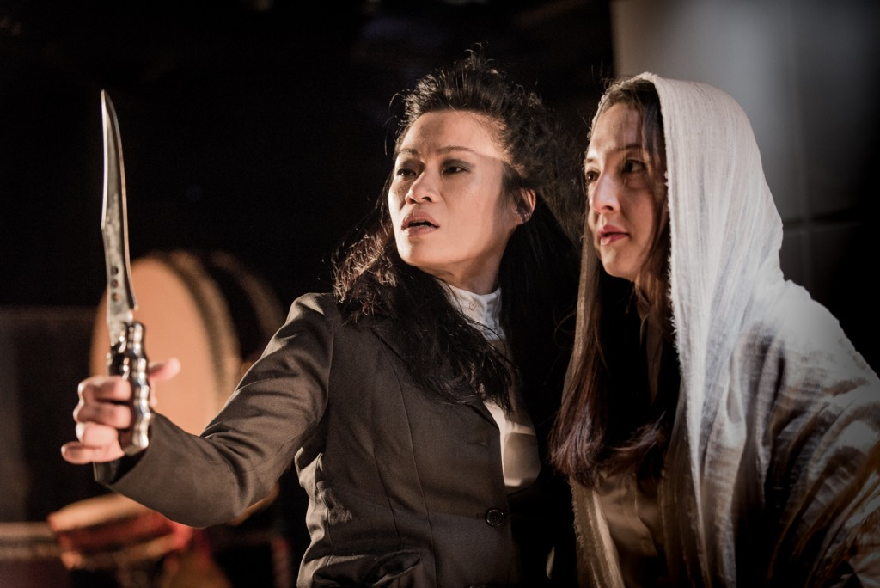
Easy Read Version

 | Z-arts
 | and
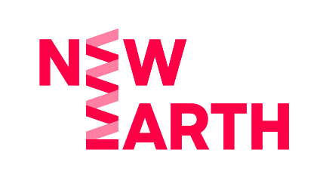 | New Earth
 | are working together
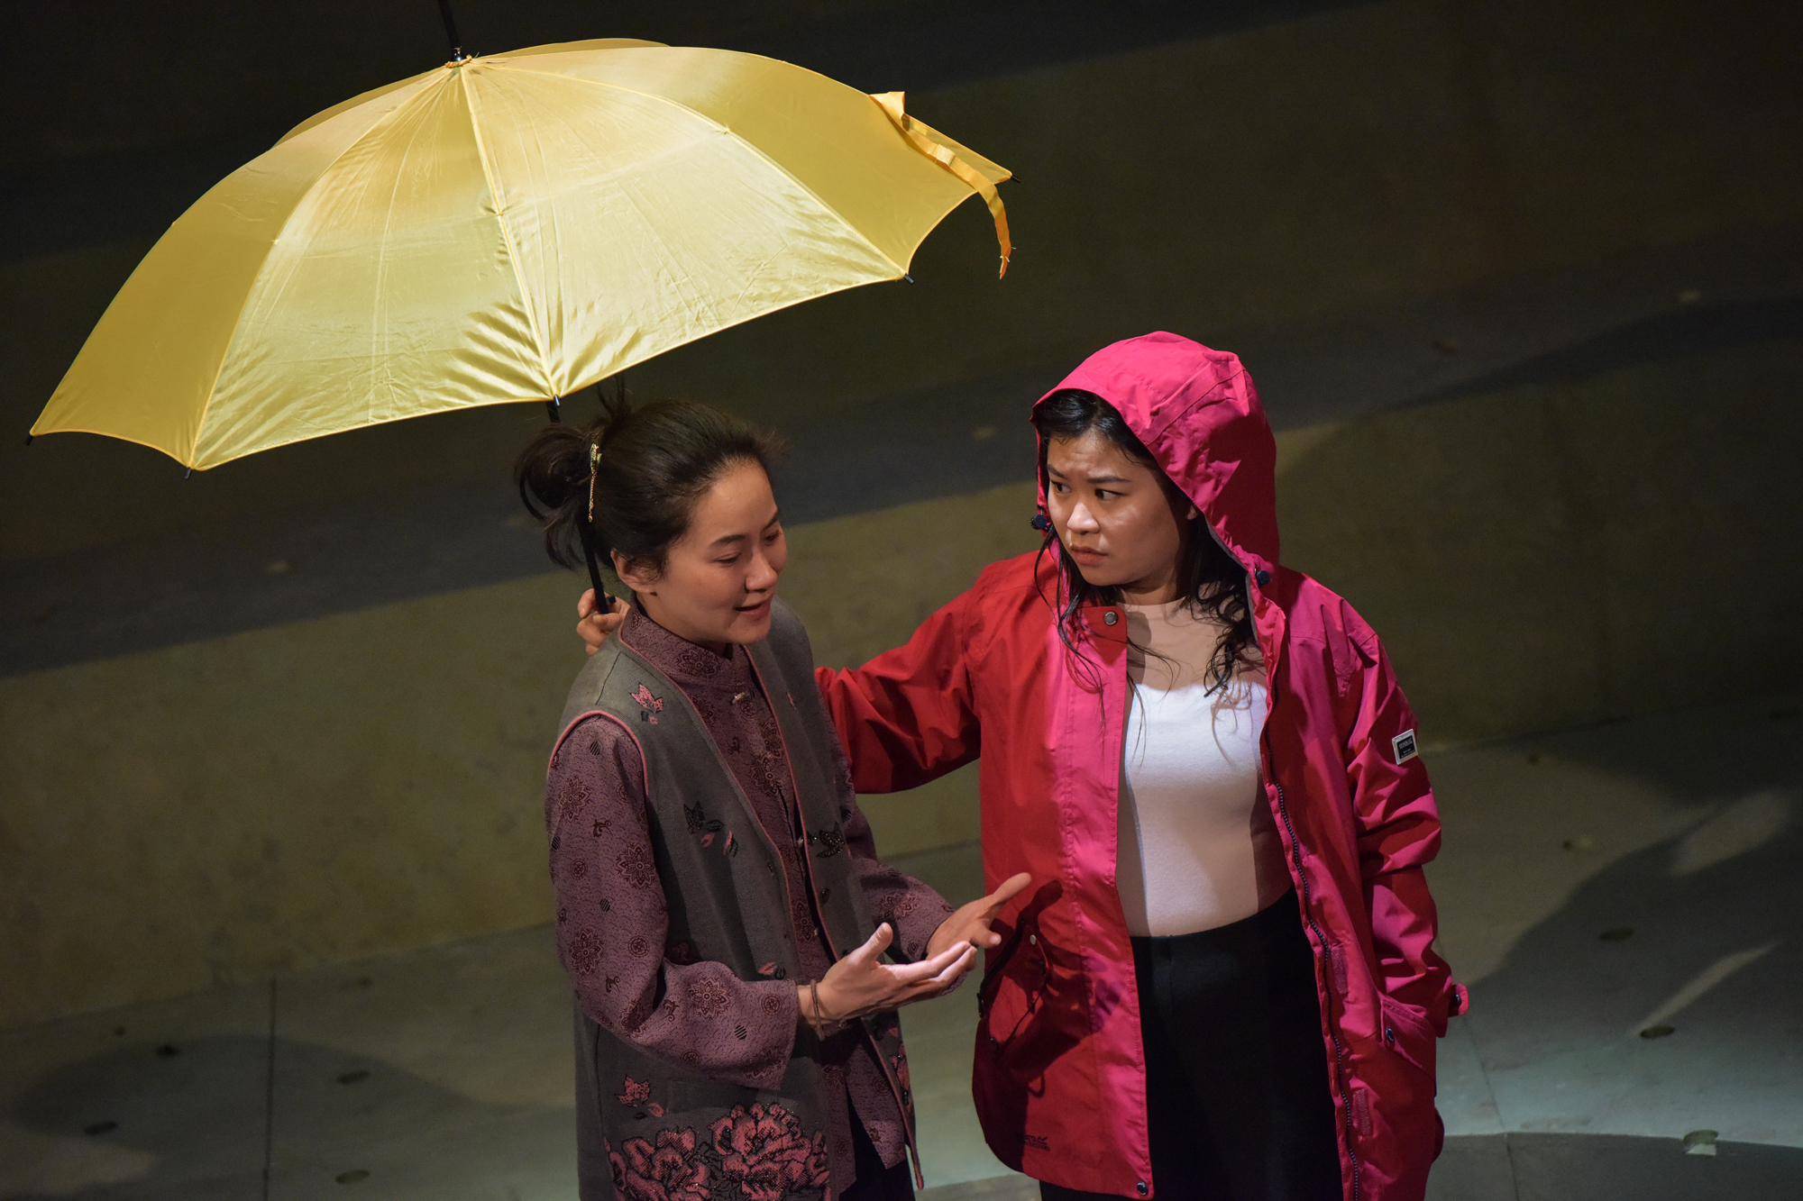 | to give British East and South East Asian (BESEA) Theatre Makers
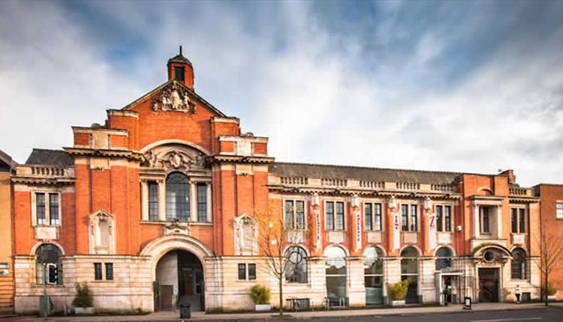 | the chance to create work in the Z-arts building.
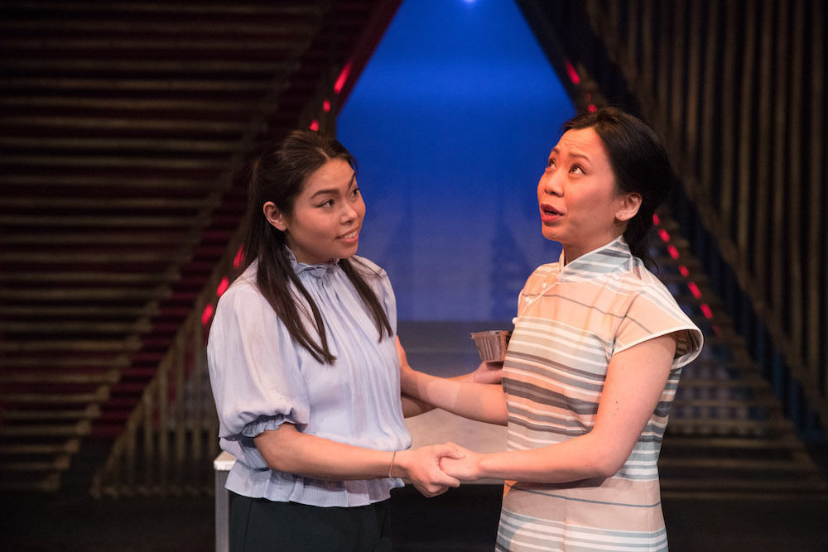 | British East and South East Asians are people of the following descent:
Brunei, Burma, Cambodia, China, East Timor, Hong Kong, Indonesia, Japan, Laos, Macau, Malaysia, Mongolia, North Korea, Philippines, Singapore, South Korea, Taiwan, Thailand, Vietnam and their diasporas.
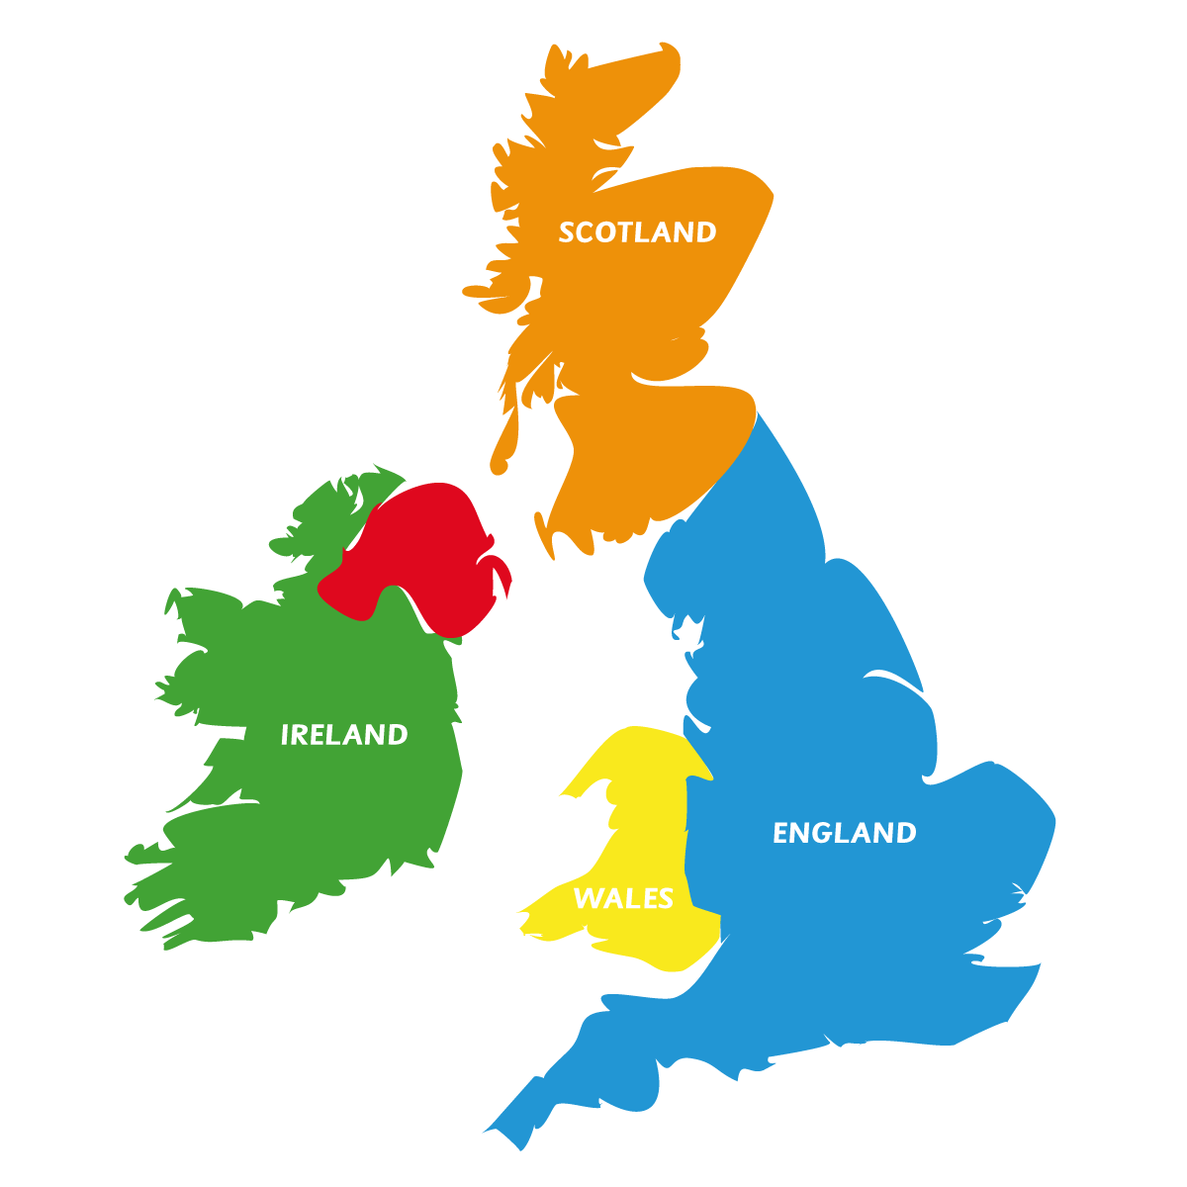 | You must live and work in the UK for this role.
 | At the moment, there aren’t many people who are British East and South East Asian making work for children and families.
 | We want to change this.
 | What we can give you
 | - 1 week using a room in Z-arts to play and come up with ideas.
The dates will be one of these weeks:

- Monday 29th November 2021 until Friday 3rd December 2021.

- Monday 6th December 2021 until Friday 10th December 2021.

- Monday 13th December 2021 until Friday 17th December 2021.

 | - On Friday 19th November 2021 at 10am you will meet people from Z-arts and New Earth Theatre at Z-arts.
 | - You will be given up to £1250 for your week at Z-arts.
 | - A one-to-one advice session on zoom after your week at Z-arts.
 | - Support and advice whilst at Z-arts.
 | - The opportunity to watch shows at Z-arts. These shows are:
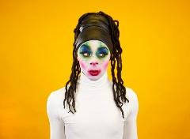 | Family Vogue Ball
 | The Gift
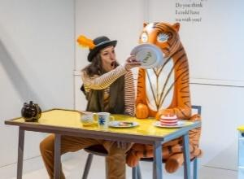 | The Tiger Who Came To Tea
 | Who we are looking to work with
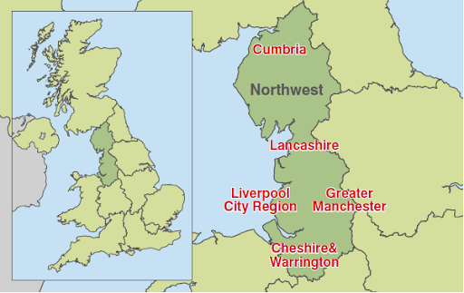 | - British East and South East Asian Theatre Makers (BESEA) based in the North West of England
 | - You must have an interest in developing work for children (12 years and under) and families
 | - If you are applying as a theatre company, the company must be led by BESEA artists, so please give details of all your collaborators
 | What we expect from you
 | You will be at Z-arts
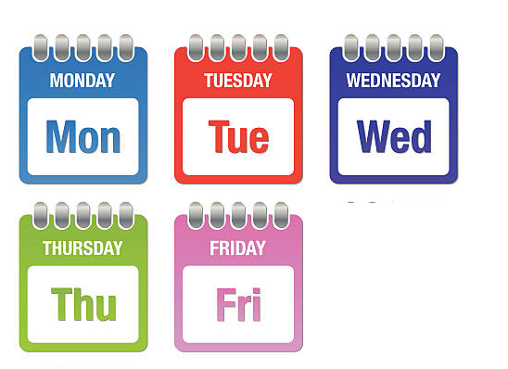 | for one week.
 | You should not use this time to create a finished performance.
 | This time should be spent coming up with ideas and having fun.
 | At the end of the week
 | you can talk about what you did
 | or show a small part of what you have been working on.
 | How to apply
 | Answer these questions.
 | Write your answers down
 | Or video yourself answering the questions:
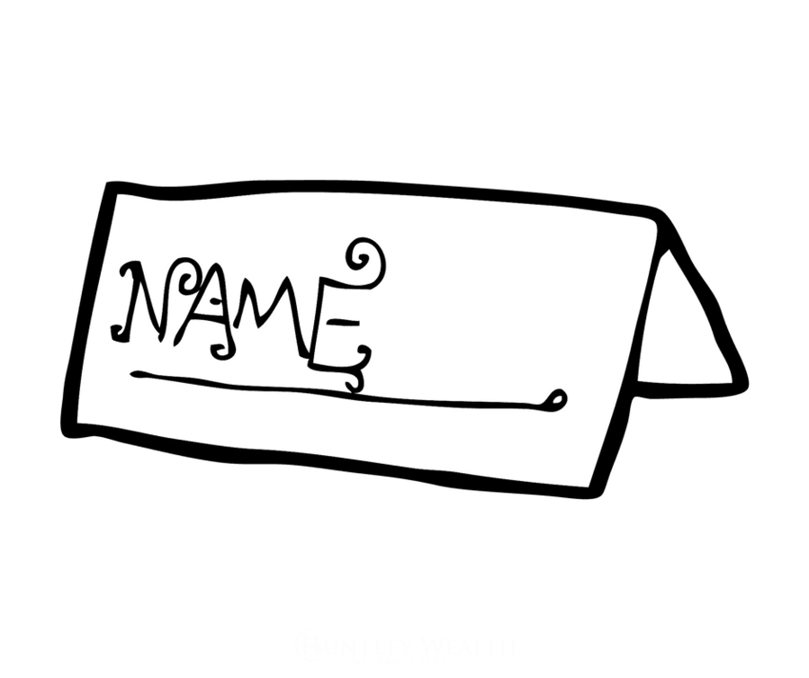 | - Name of the lead artist
 | - Email address
 | - Contact Number
 | - What professional experience do you have?
 | - Why do you want to make work for children and families?
 | - What will you do with your week in the building?
 | - Why do you think this project is for you? How will it help you in the future?
 | - As part of this project, you can receive up to £1250. What will this money be spent on?
 | - Important! Anyone who you work with needs to be paid for their time.
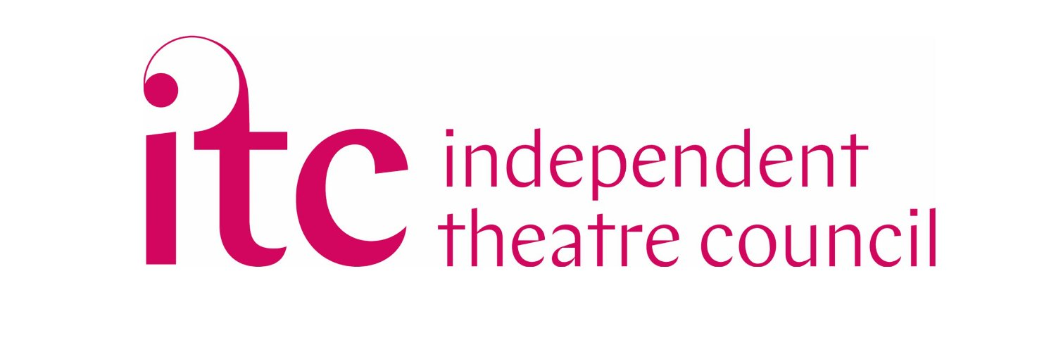 | ITC offers a rates of pay guide here
 | Where to send your answers
 | Send your answers and the Equal Opportunities form to tabitha@z-arts.org
 | Send your answers by 12 noon on Monday 1st November 2021.
 | Any questions please contact tabitha@z-arts.org or phone 01612261912 and ask to speak to Tabitha or Zoe.

