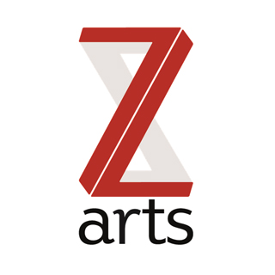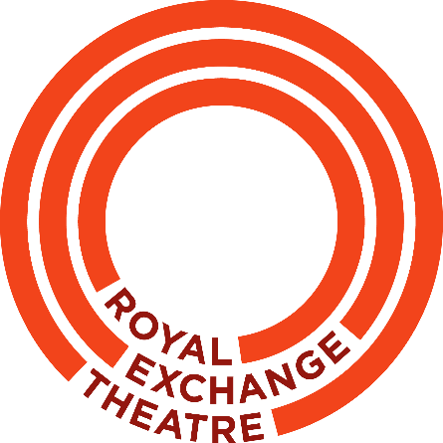

Brief for Creative Facilitator / Director
for
Theatre with Children as Commissioners

Z-arts and the Royal Exchange are looking for a dynamic theatre maker with experience of working with children to take a key role in developing a new way of making theatre for and by young people.
Each phase and each artistic choice will be led by the children, who will select the creative team, the themes and the locations.
Over the last six months we have been testing the very essence of theatre-making practice, by putting children in charge. We have been learning how to not impose our own concepts on children, encouraging them to come up with their own ideas for what kind of creative experience they would like to enjoy.
We are now looking for an artist or company who can work with the children to facilitate the creation of a theatrical experience, entirely led by them.
Background
The children we have worked with are from three different schools and demographics. We have worked across years 1 – 5 in Abraham Moss Primary School in Crumpsall, St Mary’s C of E Primary in Moss Side and Summerville Primary School in Salford.
We have now selected a core of 15 children from Year 3 (5 from each school), who will act as the initial commissioners. These children will be in Year 4 during the making period, and Year 5 for the final production. They have helped design this brief and will shortlist and interview applicants.
Themes
The strong theme that came out of this workshop phase is Adventure. The emphasis was very much on children leading their own adventure, whatever that might become from a child’s perspective.
Required Outcome
- A creative theatrical experience for children, commissioned, designed and led by children to be made in Royal Exchange Theatre, Z-arts or another location
- Audience - a significant number of young primary aged people must be able to experience it
- A process that is logged and documented, so that it may be replicated by others
Scale of budget
Up to £30,000 to be spent across the project.

Timeframe
- Artist shortlisted March/April 2020
- Interviews April 2020
- Artist works April– July 2020 with children during term time
- Intensive summer activity with children August 2020
- Development of ideas Sept – Dec 2020
- Make and present final experience Jan – March 2021

Person Specification
The children have agreed what kind of person they want to work with, which you can see in the attached video brief that they have created.
- Good Imagination
- Creative
- Know how to talk to children
- Confident
- Ready for anything
- Be themselves
Application Process
The children also decided the questions they want to ask you:

- What’s your name and what’s your experience?
- What job have you done in the past and why do you want to work with us?
- What’s your favourite film or theatre show?
- Tell us a joke.
- Describe a dream world and describe an adventure that is real or not.
- What did you feel like when you first started your job, and what do you feel like now?
- List six things that you would like to put in a show, and who would you like to work with?
- You may attach a link to a website or footage of previous work

To apply, please send a video answering all questions 1-7 to: poppy.parker@royalexchange.co.uk
(For other queries please email: gill@z-arts.org)

Deadline: 5pm on Friday 27th March

