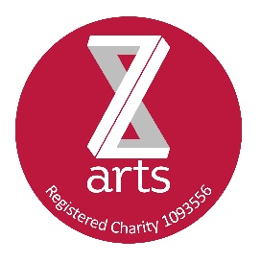
Our MIGHTY FINE
Spirits Selection

Check out our speciality Gin Bar
- 13 gins usually available,
- Chose a large or small tonic, why not try with soda and fresh lime or OJ?
- Ask your server what’s available/see bar
- £4 / £6.50
- Neat/over ice £3.00

Gin not your thing? Try our rum selection…
RUM!
- We’ve got 10 of ‘em, light and dark.
- Again, see your server to check out what’s available
- £4 / £6.50
- Neat/over ice/with an squeeeeeze £3.00

Also available;-
Chilled Grey Goose vodka
– great with fresh lime and soda
Jamesons or Bushmills Irish Whiskies
- ask for a teeny jug of cold water
Jack, Jack Honey, Jim Beam, Bulleit, Knob Creek, Makers Mark
- why not try Jack Honey with a ice and a dash of OJ
All £4.00/£6.50 or £3.00 neat/over ice

Single Malts - Laphroaig Jura Glenfiddich
£4.50/£7.50
Please don’t ask us to put coke in. We won’t.

