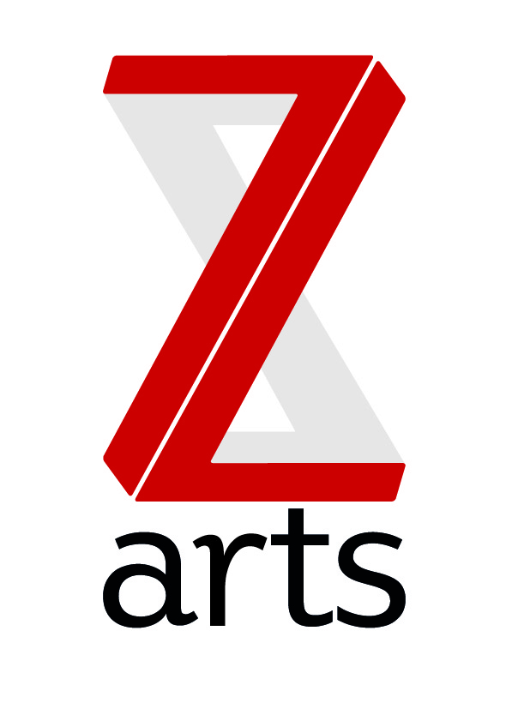

JOB DESCRIPTION

TITLE: House Manager

RESPONSIBLE TO: Head of Finance and Operations

Manchester’s primary venue for children and families, Z-arts delivers a broad range of visual and performing arts events, performances, exhibitions, activities, workshops and participatory opportunities. One of the most versatile cultural buildings in Greater Manchester, Z-arts has an excellent track record in engaging young people of all ages in creative participatory activities.

PURPOSE: To be one of two House managers at z-arts ensuring an excellent, efficient and welcoming environment for all visitors to Z-arts, and to lead on the smooth running and development of the Z-arts cafe and bar

HOURS 37.5 Hours per week
Some flexibility is required as Z-arts is open 7 days per week so weekend and evening work will be required as part of the rota.

SALARY £24,000 per annum

MAIN AREAS OF RESPONSIBILITY:

- To act as House manager for incoming shows and exhibitions (on a rota system)
- To be Duty manager, designated key holder and responsible for the opening and locking up of the building when necessary(on a rota system)
- To assist in preparing staffing rotas for the whole building
- To be responsible for the day to day running of the café/bar ensuring that high standards of cleanliness, food hygiene and customer service are maintained.
- To line manage the Deputy House manager (café) and casual FOH staff
- Responsible for the preparation and selling of food, beverages and alcoholic drinks
- Responsible for the preparation of buffet lunches for room hires and meetings
- Ordering and maintaining levels of stock and monitoring wastage
- Developing the menu and ensuring profit margins are maintained
- Responsible for ordering and stock control of food, beverages and cleaning products and consumables or any additional stock changes or requirements.
- To work with the Head of Finance and Operations to investigate opportunities for increasing the revenue in the café through events or partnering opportunities.
- To prepare rooms for all bookings and events, including for the following days activities, liaising with the relevant departments and to undertake regular room checks.
- To work with the entire staff team to support and deliver Z-arts strategic and creative vision.
- To understand, actively promote and adhere to Health & Safety legislation and Z-arts Health and Safety policy.
- To adhere to all Z-arts policies and procedures

Person Specification

The successful candidate will be able to demonstrate the following:

- Previous experience in a similar environment
- Ability to prepare and serve a range of simple snacks and sandwiches
- Ability to use an espresso machine.
- Experience of cash handling.
- A friendly and welcoming demeanour, including with children and families
- Ability to work effectively under pressure and deal with conflicting demands.
- Ability to demonstrate strong communication skills.
- Ability to lead a diverse team and cooperate with others.
- Excellent time keeping skills, conscientious and punctual.
- Excellent standard of personal presentation and hygiene.
- An understanding of equal opportunities practices.

The following attributes would be desirable:

- Level 2 Food hygiene certificate or above
- Personal Licence holder

