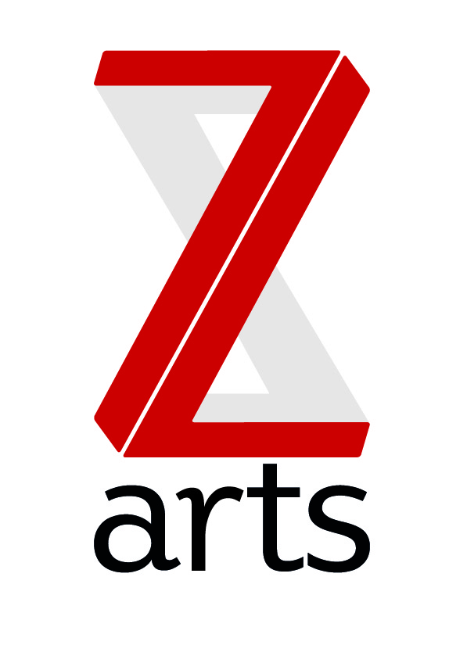

JOB DESCRIPTION

TITLE: Resident Dance Facilitator

RESPONSIBLE TO: Head of Creative Development

Z-arts, Manchester’s dedicated venue for children and families, is seeking a dance facilitator specialising in dance to join the creative team.
Dedicated to inspiring creativity, Z-arts delivers a broad range of visual and performing arts events, performances, exhibitions, activities, workshops and participatory opportunities. One of the most versatile cultural buildings in Greater Manchester, Z-arts has an excellent track record in engaging young people of all ages in creative participatory activities and a new ambition to become Manchester’s primary venue for children and families.

PURPOSE: The successful applicant will be responsible for ensuring an excellent, efficient and welcoming environment for all dance participants to Z-arts and have specific responsibility for the smooth running of Z-arts dance studio and dance sessions.
Styles of dance: contemporary ballet, urban tap and street dance for 5-7 and 8-11 years.
HOURS 15 hours per week
Dance classes are Monday 4:15 – 5:45pm, Thursday 4:15 – 5:45pm and Saturday 9:30 – 11:00 and 11:30 1:00pm (6 hours delivery)
A good deal of flexibility is necessary as this role involves evening and weekend work. The split of the role is subject to change as and when the timetable changes.
MAIN AREAS OF RESPONSIBILITY:
Engagement
- To take the lead in the dance programme; to mentor young people and develop training programme for individuals and the community to develop their skills in creativity and dance-making.
- To devise and deliver workshops & support masterclasses & deliver our regular sessions supporting our young people on dance creation.
- Expand on our outreach strategy to engage more young people & community groups.
- Monitor, measure and evaluate the programme through data, highlighting progress outcomes and any risks. Actively encouraging youth led evaluation through creative means to record and document things that matter to participants.
General
- To work with the creative team and entire staff team to support and deliver Z-arts strategic and creative vision.
- To understand, actively promote and adhere to Health & Safety legislation and Z-arts’ Health and Safety policy.
- To adhere to all Z-arts policies and procedures.
- Any other duties required by the Senior Management Team
Person Specification
Essential Skills
- Experience of working with young people, artists and community
- Ability to enhance students abilities
- Experience of dance sessions management
- Experience of lesson planning and evaluating
- Experience of organising events
- Up to date DBS or willingness to get one
Desirable:
- Experience of working with young people from diverse backgrounds
- Knowledge of the dance, arts and cultural scene in Greater Manchester
- Degree or equivalent qualification in dance related subject
- Experience of working with support facilitators
- Knowledge of and experience of SEN and additional needs
- Safeguarding knowledge
Person Skills
- Excellent interpersonal skills and ability to work within a diverse team
- Excellent communication skills, both verbal and written
- Ability to build and sustain good working relationships
- Ability to exercise initiative and take personal responsibility
- Excellent organisational skills
- Strong time management skills
- Attention to detail
To comply with legislation covering the activities at Z-arts, it is required that all staff undertake training as directed by their line manager. It is also essential that all staff carry out their duties in a safe manner in accordance with the current Health and Safety at Work legislation.

