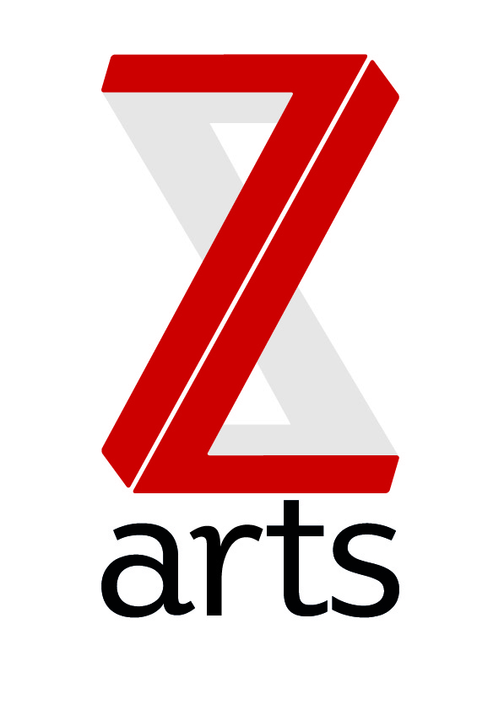
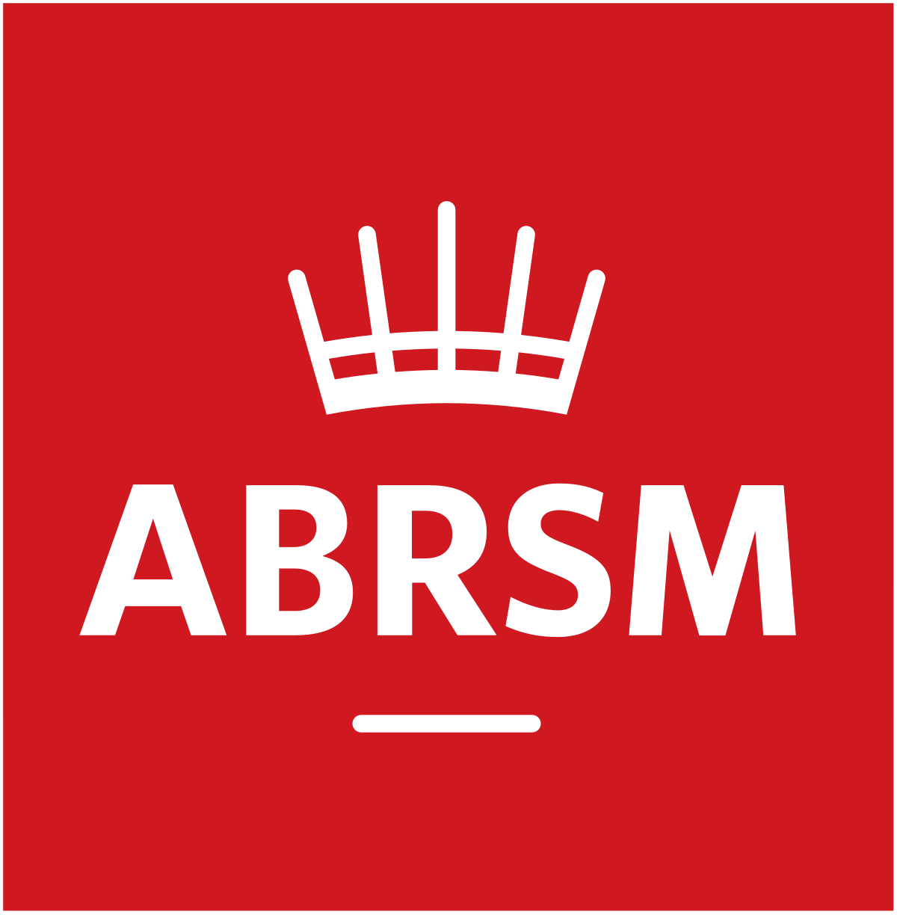
Generation Z application Form
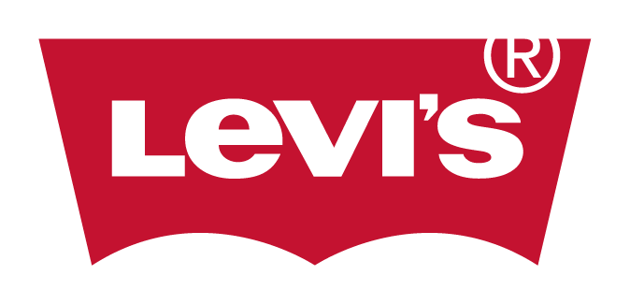
Generation Z is a brand new FREE project for young musicians to develop skills in writing, performance and creativity. In weekly sessions starting Feb 2020, you will be working with some of the top musicians from across the Manchester music scene in a brand new state of the art recording studio.

If you are aged 11-16 and would like to take part in this project, please complete the form below and return to jack@z-arts.org or the address below by February 14th 2020 at 5pm

We will you know if your application has been successful by Tuesday 18th Feb

Return Address: Z-arts 335 Stretford Road, Hulme, M15 5ZA
Email: jack@z-arts.org Phone: 0161 2261912

Generation Z Application form

Full name………………………………………………………………………………………………….
DOB…………………………… Age…………… Gender………...........................................

Do you have any access requirements?........................................................................................

Email address:…………………………………………………………………………………………….

Parent/Guardian
Name: …………………………………………………………………………………………….
Relationship to young person: ………………………………………………………………………………………
Address: …………………………………………………………………………………………….
Mobile Number: ……………………………………………………………………………………………

If possible, please attach an example of your music along with your application. This could be an MP3 or WAV file, a soundcloud/youtube/spotify link, video, recording on a phone. If you do not have an example of music to send, we can arrange a face to face meeting. Please specify below.

- Would you like to arrange a face to face meeting on Monday 10th feb as part of your application?.......................................................................................................................

- What music do you make and how?
Eg. I learn classical and jazz music on the Clarinet or I make trap beats on FL
………………………………………………………………………………………………….

- What are your biggest achievements in music so far?
……………………………………………………………………………………………………………………………………………………………………………………………………………………………………

- What specific skills are you looking for or areas are you hoping to develop in? ……………………………………………………………………………………………………………………………………………………………………………………………………………………………………

- How did you find out about the project?..............................................................................................................................................

- Sessions will take place at Z-arts on Mondays starting 24th Feb - 20th July (term time only). Are you able to attend sessions at

- 16:00-17:30 B) 17:30-19:00 C) Either

I agree that I can make all the dates. If selected for the project I will be giving consent to be photographed and filmed for promotional purposes throughout the project by both Z-arts and ABRSM

Signed: ……………………………………………………………… Date:…………………………

If you have any questions about this form or the project please do not hesitate to contact us on jack@z-arts.org or call 0161 226 1912

