The Levi’s® Music Project

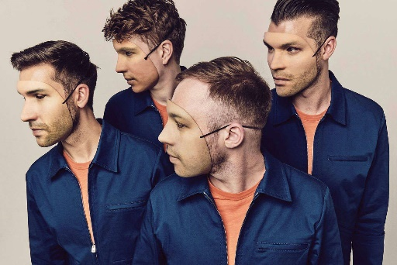
The Levi’s® Music Unity Project is an exciting 2-week project that will bring together 12 young people and Mercury Prize nominated Everything Everything to on an exciting 2 week project.

You will be based in a brand-new purpose-built studio at Z-arts in Hulme, Manchester. The aim of the project is to create work and build your understanding as an artist.

During the project as well as working in a studio to create the work, you will also take part in master classes, which will cover different aspects of performance and being an artist. Master classes will include Sound Design, Social Media and Live Performance Creation.

This is an incredible and unique opportunity to work alongside industry professionals and with other young people.

Rehearsal Schedule and Performance Dates:
Date | Times | Venue
Tuesday 29th August | 11am - 3pm | Z-Arts
Wednesday 30th August | 11am - 3pm | Z-Arts
Thursday 31th August | 11am - 3pm | Z-Arts
Friday 1st September | 11am - 3pm | Z-Arts
Saturday 2nd September | 11am - 3pm | Z-Arts
Sunday 3rd September | 11am - 3pm | Z-Arts
Monday 4th September | 4pm - 8pm | Z-Arts
Tuesday 5th September | 4pm - 8pm | Z-Arts
Wednesday 6th September | 4pm - 8pm | Z-Arts
Thursday 7th September | 4am - 8pm | Z-Arts
Friday 8th September | 4pm - 8pm | Z-Arts
Saturday 9th September (Z-arts Performance) | TBC (Daytime) | Z-Arts
TBC Final Performance in London! | TBC | TBC

If you are aged 15-21 and would like to take part in this project please complete the form on the reverse and return to Z-Arts by Monday 14th August at 5pm

We will then let the successful applicants know by Tuesday 15th August.

Return Address: Z-arts 335 Stretford Road, Hulme, M15 5ZA
Email: lmp@z-arts.org Phone: 0161 2261912

The Levi’s® Music Project application form

Full name………………………………………………………………………………………………….
DOB…………………………… Age…………… Gender………...........................................
Do you identify as Disabled or consider yourself to have a disability?……………………………...
Do you have any access requirements?........................................................................................
Address …………………………………………………………………………………………….
Mobile: …………………………………………………………………………………………….
Email address:…………………………………………………………………………………………….

If under 18 years old, please complete contact details for your parent or carer:
Name: …………………………………………………………………………………………….
Relationship to you: ………………………………………………………………………………………
Address: …………………………………………………………………………………………….
Mobile Number: ……………………………………………………………………………………………

Please do let us know of any online material you have as an artist or performer. If you do not have any online material currently, please do not worry, simply record yourself via your phone or laptop camera (Max 60 seconds) showing us why you would like to be a part of this experience or a display of your skills. Please send your video files attached to an email along with the completed forms to the email address supplied above.

- Why do you want to be involved with the Levi’s® Music Project?
………………………………………………………………………………………………….
………………………………………………………………………………………………….
…………………………………………………………………………………………………..
………………………………………………………………………………………………….
- What music skills do you currently have? What is your musical ambition?
………………………………………………………………………………………………….
………………………………………………………………………………………………….
…………………………………………………………………………………………………..
………………………………………………………………………………………………….
I agree that I can make all the dates outlined in the rehearsal and performance schedule and understand that I must be a part of the whole project. If selected for the project I will be giving consent to be photographed and filmed throughout the project by all partners.

Signed: ……………………………………………………………… Date:…………………………

For those under 18 years old:

Parent/Carer Signed:……………………………………………… Date:…………………………

