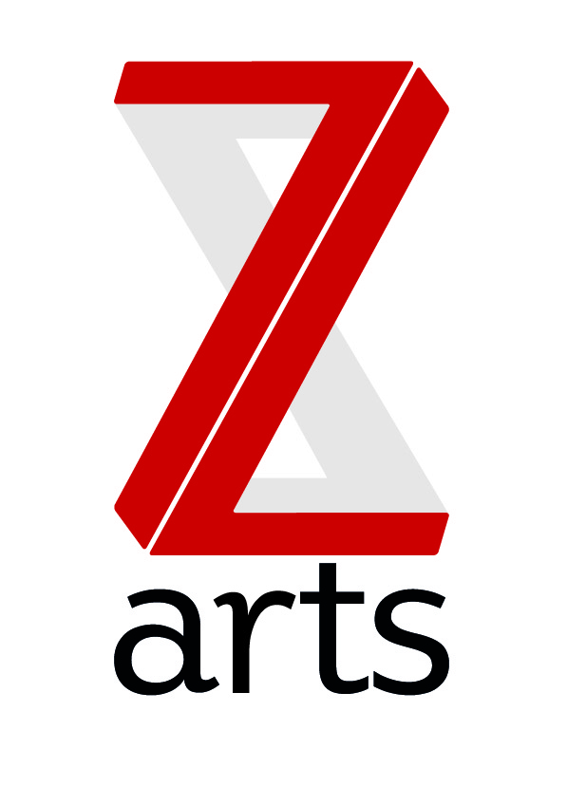

Manchester's venue for children and families seek a new treasurer.

The opportunity has come up for a voluntary position to take the role of Treasurer on the Z-arts Board of Trustees, following the end of term for our current treasurer, who works in the private sector as Finance Director of a large north west based property investment business.

The successful applicant would be expected to donate a minimum of 60 hours per year to treasurer duties, including preparing for and attending meetings and events.

What is Z-arts?

Z-arts is Manchester’s venue for children and families. Our mission is to inspire and enable generations of young people from across Manchester and beyond to utilize their creativity to maximise their potential. We operate from a large Edwardian building which includes a 230 seat theatre, gallery, recording studio, music room, dance studio, café and numerous other rehearsal / meeting rooms. Based in Hulme, we are committed to supporting our local communities as well as reaching out across the whole of Manchester and increasingly across the North West.

Z-arts is in a position of strength with a strong staff team, stable financial base and a clear, focused artistic vision

- We are one of five cultural organisations in receipt of strategic funding from Manchester City Council, with a remit to lead on best practice for engaging children and young people in arts and culture.
- We are in receipt of three years of Arts Council England Strategic Touring Funds to lead and deliver the Big Imaginations regional network of children’s theatre.
- We are in receipt of three years’ funding from Children in Need to support our Bright Sparks programme, which offers children and young people free creative workshops across all artforms, every day of the week.
- Our CEO Liz O’Neill, is a recipient of the Paul Hamlyn Foundation Breakthrough Fund, awarded to creative cultural entrepreneurs.
- We are gaining a reputation for breaking new ground in producing outstanding contemporary theatre and interdisciplinary art for children and families.
- Our visitor numbers have increased each year from 8,000 in 2009 to 52,000 last year.
- Over 11,000 children and adults taking part in our regular activities every year.
- We have a turnover of over £800,000, which is roughly split three-ways between core funding from Manchester City Council; project funding and earned income (hire of spaces, creative commissions and box office).
- We are governed by a dedicated team of trustees, who oversee organisational growth and provide strategic guidance.

Treasurer Job Description

Financial
- To lead on trustee scrutiny of the organisation’s financial records, regulations and practices, including reviewing quarterly management accounts, monitoring bank payments and ensuring financial regulations are maintained.
- To Chair the quarterly finance sub-committee meetings and report to all trustees on any matters arising.
- To represent the trustees of Z-arts on financial matters when required.
- To review annual budgets and propose authorisation to the full board.
- To advise on financial implications of strategic plans.
- To ensure the organisation provides good governance at all times.
- To act as a signatory on Z-arts bank accounts.
- To work with the CEO and General Manager on appointment of auditors, auditor relations and lead on the trustee report for the annual accounts.
- To hold responsibility for the audit to be signed off within timeframe and ensure that annual reports are submitted to Companies House and the Charities Commission.
General
- To attend an annual strategic planning day.
- To attend events regularly at Z-arts, including special VIP events and other regular activities, to promote better understanding of the core offer of the organisation.
- To act as ambassadors for the organisation, both internally at Z-arts and in everyday life.
- To support fundraising and development campaigns by introducing friends and colleagues to the organisation; assisting in any social media campaigns and attending seminars or training where necessary.

Person Spec.
We are looking for an experienced professional in the finance sector to take up this role. Some sectors of our society are currently under-represented on our board and we would particularly welcome applications from people from Black, Asian and Minority Ethnic groups or people with disabilities. Unusually, we currently also have a lack of men on the board.

How to apply
If you are interested in applying, please email chair@z-arts.org with a CV and an expression of interest stating why you are interested in becoming a Z-arts treasurer and what skills you think you would bring to the role.
Alternatively, if you would like to discuss this opportunity first, please call our CEO Liz O’Neill on 0161 232 6076 or email liz@z-arts.org for an informal chat.

Deadline: 12pm - Friday 28th October 2016
The next full board meeting at Z-arts will be held on 13th December. We anticipate an incoming treasurer to attend that meeting as an observer.

