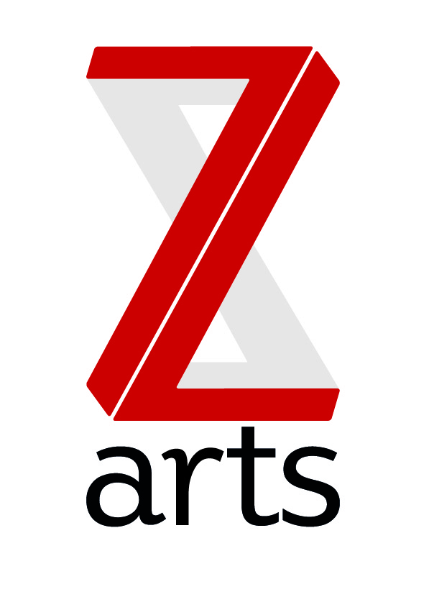

JOB DESCRIPTION

TITLE: Technical Manager

RESPONSIBLE TO: General Manager

RESPONSIBLE FOR: Technical Assistant

Manchester’s venue for children and families., Z-arts is dedicated to inspiring creativity in generations of young people by delivering a broad range of visual and performing arts events, performances, exhibitions, activities, workshops and participatory opportunities. One of the most versatile cultural buildings in Greater Manchester, Z-arts provides a resource to individuals and groups who hire facilities in the venue and this income makes a strategically important contribution to our turnover.

PURPOSE:
To provide smooth and efficient technical services to the organization, with due care for Health & Safety; for all events with particular focus on the theatre.

HOURS
The hours of the role are 40 per week but the requirements of the business are such that a high degree of flexibility is necessary and evening and weekend work will be a required as part of your rota.
You will be expected to spend equal time in the office and teching shows.

MAIN AREAS OF RESPONSIBILITY:
- To ensure adequate professional technical cover (including light, sound, AV) of the highest standard is provided for all events at Z-arts
- To liaise with Z-arts staff and customers in advance and during their event, on all technical aspects of their event including staff and resources required; providing all their technical requirements within agreed timescales and budgets.
- To be responsible for the timely application of all technical administrative procedures including uploading technical information to Artifax and accurate record keeping is up to date.
- To liaise with creative, programming, events and front of house departments, providing accurate up-to-date schedules and to ensure a smooth running of all events.
- To manage the technical assistant, freelancers, trainees or volunteers to ensure a high standard of technical cover is provided whenever required,
- To maintain compliance with current legislation and Approved Codes of Practice, keeping up to date with changes in legislation.
- To be responsible for the maintenance, storage, security and safety of all technical equipment, including the theatre space and annual PAT-testing.
- To be responsible for the technical maintenance budget, providing purchase orders to finance department for all purchases of equipment consumables and additional staff
- To play an active role in the Health & Safety Committee
- To provide a welcoming and efficient customer service at all times.
- To provide workshops and training to young people on all aspects of technical theatre.

General
- To act as a Duty Manager, designated key holder and IRT (Incident Response Team) member as and when required.
- To work with the board and entire staff team to support and deliver Z-arts strategic and creative vision.
- To understand, actively promote and adhere to Health & Safety legislation and Z-arts’ Health and Safety policy.
- To adhere to all Z-arts policies and procedures.
- Any other duties required by the Senior Management Team.

GENERAL INFORMATION:
To comply with legislation covering the activities at Z-arts, it is required that all staff undertake training as directed by their line manager. It is also essential that all staff carry out their duties in a safe manner in accordance with the current Health and Safety at Work legislation.

Person Spec
Experience:
- At least 3 years’ experience working as a key member of a technical department in an arts venue.
- Proven experience in the rigging, operation and maintenance of a wide range of Lighting, sound and AV equipment
- Experience and proven ability to manage budgets, record keeping, IT systems and administration
- Detailed knowledge of responsibilities under Health and Safety legislation, and experience of ensuring that these are in place within an arts or entertainment venue.
- Knowledge and experience of using the latest technology
Characteristics
- Ability to exercise initiative and take personal responsibility.
- Ability to work effectively under pressure and deal with conflicting demands.
- Ability to work well in diverse team and cooperate with others.
- A calm manner
- A professional attitude
- Problem solving; interpersonal skills

