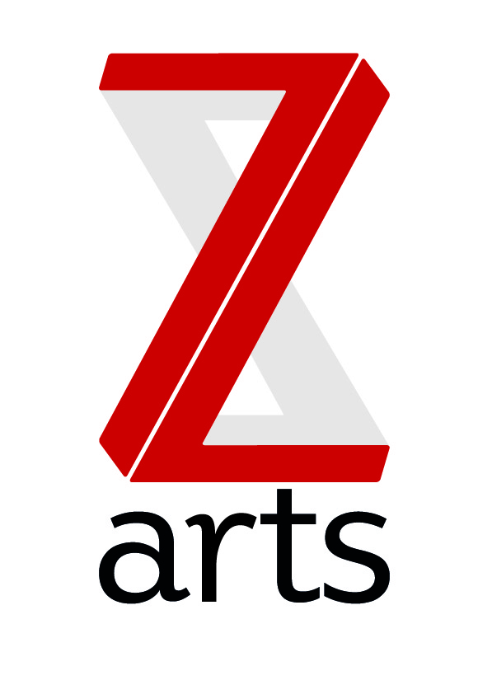

JOB DESCRIPTION

TITLE: Marketing Officer

RESPONSIBLE TO: CEO

Dedicated to inspiring creativity, Z-arts delivers a broad range of visual and performing arts events, performances, exhibitions, activities, workshops and participatory opportunities. One of the most versatile cultural buildings in Greater Manchester, Z-arts has an excellent track record in engaging young people of all ages in creative participatory activities and a new ambition to become Manchester’s primary venue for children and families.

PURPOSE:
To actively promote all aspects of the work of Z-arts; to promote and encourage greater awareness and participation in all Z-arts workshops and classes and to increase overall attendance at all Z-arts performances and events.

HOURS
The hours of the role are 37.5 per week but the requirements of the business are such that a high degree of flexibility is necessary and evening and weekend work will be a required as part of your rota.

MAIN AREAS OF RESPONSIBILITY:
- To sustain and implement our marketing plan for all Z-arts activities and to increase brand awareness, footfall and associated income.
- To update the Z-arts website with details of all events, classes and performances through the content management system
- To write copy for all Z-arts events and activities for use in different media (brochures, mailouts, online etc)
- To write and distribute press releases
- To create and distribute a monthly Z-arts newsletter (using mailchimp)
- To maintain, develop and add to a growing marketing database
- Engage with and monitor the operation of the Z-arts Social Media Strategy
- To actively promote the Z-arts café and associated activities
- To work with box office team to run any sales promotion strategies and to improve data
- To manage and maintain positive relationships with media partners
- To liaise with designers to produce all promotional material
- To assist in the promotional opportunities and ideas from conception through to delivery.
- To analyse available data and report to the SMT on the effectiveness of different marketing campaigns
- To be jointly responsible for the marketing budget.
General
- To act as a Duty Manager and IRT (Incident Response Team) member as and when required.
- To work with the board and entire staff team to support and deliver Z-arts strategic and creative vision.
- To understand, actively promote and adhere to Health & Safety legislation and Z-arts’ Health and Safety policy.
- To adhere to all Z-arts policies and procedures.
- Any other duties required by the Senior Management Team.

GENERAL INFORMATION:
To comply with legislation covering the activities at Z-arts, it is required that all staff undertake training as directed by their line manager. It is also essential that all staff carry out their duties in a safe manner in accordance with the current Health and Safety at Work legislation.

PERSON SPECIFICATION:
- Educated to degree standard or highly experienced in a marketing discipline
- Knowledge of the arts and cultural scene in the North West
- Ability to manage online elements of marketing campaigns including social networking
- Ability to write and source good copy for marketing material and website
- Excellent communication and networking skills
- Knowledge of Microsoft office and excel
- Self-motivated and resourceful
- Strong organisation and time management skills
- Ability to demonstrate attention to detail
- Ability to work under pressure and to tight deadlines
- Ability to analyse data and compile reports
- Ability to maximize returns from a tight budget
- Enthusiasm and imagination
- Excellent interpersonal skills and ability to work within a diverse team

The following attributes would be desirable:
- Understanding of PPC and SEO
- Experience of box office systems
- Ability to prioritise own workload

