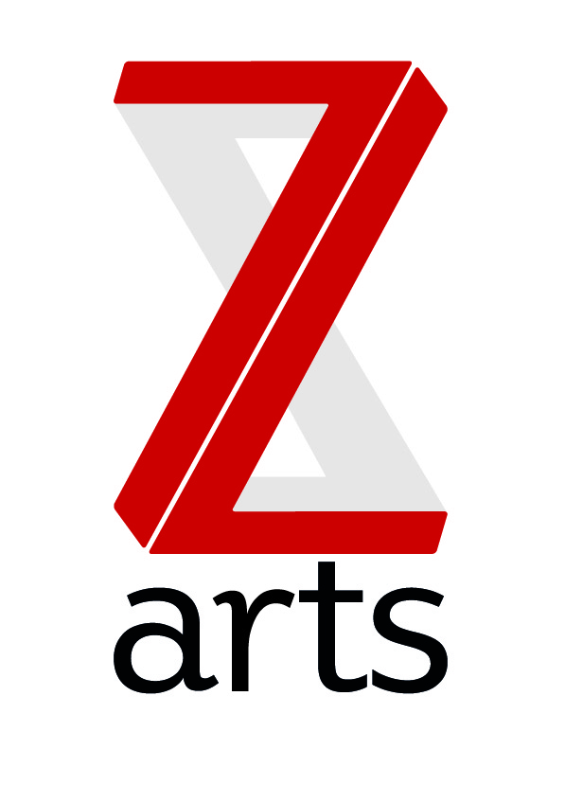

JOB DESCRIPTION

TITLE: Finance and administration officer

RESPONSIBLE TO: General Manager

Z-arts is Manchester’s venue for children and families, delivering projects and activities in our large Edwardian building in Hulme, in schools and community settings, working locally, regionally and nationally. Last year over 20,000 people took part in a creative activity from Z-arts and 53,000 people came through the building.
Dedicated to inspiring creativity, Z-arts delivers a broad range of visual and performing arts events, performances, exhibitions, activities, workshops and participatory opportunities.

PURPOSE:
To provide financial and administrative assistance to the whole organization, performing the day to day tasks of the finance department, maintaining and updating all financial records, preparing contracts, managing spreadsheets and databases and generally supporting the office, in particular the Big Imaginations programme.

HOURS
The hours of the role are 37.5 hours per week

MAIN AREAS OF RESPONSIBILITY:

Financial
- Sales Ledger, daily processing of sales invoices, credits and receipts on sage accounts

- Cash Takings, daily accounting for the cash takings from: - Box Office and Café/Bar.

- Purchase Ledger, daily processing of Purchase Invoices, Credit Notes, dealing with queries and raising Debit Notes.

- Bank, daily inputting and banking of sales and cash receipts, pay suppliers or cash purchases by bacs or cheque and daily reconciliations of all bank accounts.

- Petty Cash, completion of petty cash forms ensuring receipts are correct, approved by appropriate person, weekly input to Sage and reconciliation.

- Nominal Ledger, Inputting and recording of journal entries including prepayments and accruals.

- Credit control, chase outstanding debtors as and when required

Administration
- Databases & spreadsheets: keeping all information up to date, in particular Big Imaginations data from partner venues across the North West.

- Preparing and sending contracts to theatre companies and artists

- Taking minutes for internal staff meetings and external partner meetings e.g. Big Imaginations and Family Arts Networks.
- Creating a range of documents using word, excel and powerpoint
Office support
- Manage office supplies
- Maintain and update HR records and systems
- Researching and providing information to the senior management team.
General
- To work with the entire staff team to support and deliver Z-arts strategic and creative vision.

- To understand, actively promote and adhere to Health & Safety legislation and Z-arts Health and Safety policy.

PERSON SPECIFICATION:
Essential
- Excellent demonstrable skills in Microsoft Office and Excel
- Strong organisational and time management skills
- Ability to demonstrate attention to detail
- Excellent interpersonal skills and ability to work within a diverse team
- Excellent communication skills, both verbal and written
- Ability to build and sustain good working relationships
- Ability to exercise initiative and take personal responsibility
- A fast learner
- Interest in working in a creative environment.

Desirable:
- AAT qualified or at least two years’ experience as book Keeper / financial officer
- Working Knowledge of Sage 50 Accounts software
- Experience of box office systems
- Knowledge of the arts and cultural scene in the North West

To comply with legislation covering the activities at Z-arts, it is required that all staff undertake training as directed by their line manager. It is also essential that all staff carry out their duties in a safe manner in accordance with the current Health and Safety at Work legislation.

