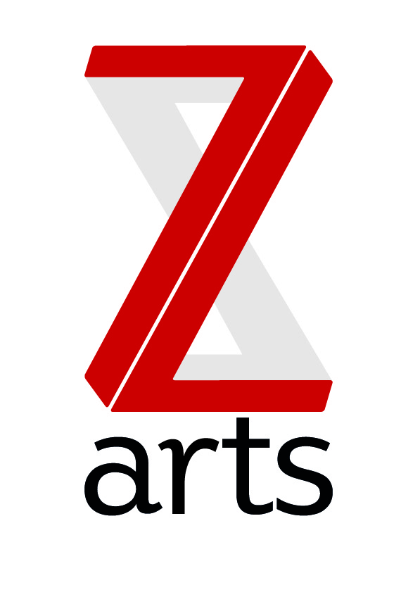

JOB DESCRIPTION

TITLE: Part time FOH assistants

Manchester’s venue for children and families, Z-arts is dedicated to inspiring creativity in generations of young people by delivering a broad range of visual and performing arts events, performances, exhibitions, activities, workshops and participatory opportunities.

PURPOSE:
To support the FOH team in ensuring an excellent, efficient and welcoming environment for all visitors to Z-arts, working in our café bar including food preparation, stewarding for theatre shows/events and providing an excellent visitor experience.

HOURS
The hours of the role will vary dependent upon the needs of the business and a high degree of flexibility is necessary as evenings and weekend work will be a required as part of your rota. It is envisaged that the successful applicants will be expected to work 10 – 15 hours per week although more hours may be available at busier times.

MAIN AREAS OF RESPONSIBILITY:

- Acting as a steward for z-arts shows and events

- Preparation and Service of food and drink (alcoholic and non-alcoholic) to customers in a polite, friendly helpful manner

- Maintaining café stock level and preparing lists for re-ordering of stock

- Keeping café area clean and tidy, clearing away used dishes & cutlery from tables when customers are finished and preparing the tables ready for the next customers.

- Operation of an electronic cash register

- Assisting in Monthly stock take procedures

- Keep up-to-date with Z-arts programme of work, box office and building information etc, so as to effectively advise customers.

- Take part in any extra training as required, and take a proactive approach in remaining aware of Café Bar Policies.

- Keep the bar and kitchen areas clean and tidy at all times, clearing the floor of any rubbish as and when needed.

- Maintain high standard of cleanliness on café equipment; coffee machines, ice machine & glass washer

- Assist in the maintenance of all-necessary fire and Health and Safety Regulations and to take emergency action as required in the event of an evacuation or similar event within the building.

- To work with the entire staff team to support and deliver Z-arts strategic and creative vision.

- To understand, actively promote and adhere to Health & Safety legislation.

- To adhere to all Z-arts policies and procedures.

PERSON SPECIFICATION:

The successful candidate will be able to demonstrate the following:

- Experience of working in a customer focused environment with responsibility for delivering excellent customer service.
- Ability to demonstrate strong communication skills, both verbal and written.
- Experience of building and sustaining good working relationships.
- A friendly, confident and outgoing personality.
- Ability to exercise initiative, work with minimum supervision and take personal responsibility.
- Ability to work effectively under pressure and deal with conflicting demands.
- Ability to work well in diverse team and cooperate with others.
- Excellent time keeping skills, conscientious and punctual.
- Excellent standard of personal presentation.
- An understanding of equal opportunities practices.

The following attributes would be desirable:

- Experience of working in a multifunctional, creative environment
- Previous experience in a catering and hospitality background
- First aid training

