Z-arts seeking a new Chair

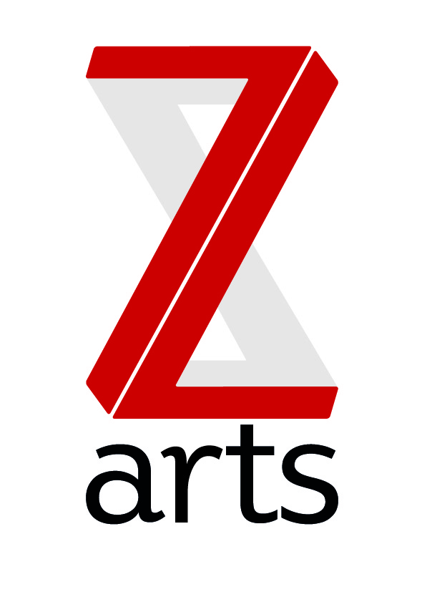

Z-arts is Manchester’s venue for children and families. We operate from a large Edwardian building which includes a 230 seat theatre, gallery, recording studio, music room, dance studio, café and numerous other rehearsal / meeting rooms.

Based in Hulme, we are committed to supporting our local communities as well as reaching out across the whole of Manchester and increasingly across the North West.

Our ambition is to provide an artistic programme that reflects and stimulates the twenty-first century contemporary family, embracing all its diversity.

Our mission is to inspire and enable generations of young people from across Manchester and beyond to utilise their creativity to maximise their potential.

Z-arts is in a position of strength with a strong staff team, stable financial base and a clear, focused artistic vision.

- We are one of five cultural organisations in receipt of strategic funding from Manchester City Council to deliver the youth arm of the City’s cultural ambition.
- We are in receipt of three years of Arts Council England Strategic Touring Funds to lead and deliver the Big Imaginations regional network of children’s theatre.
- We are in receipt of three years’ funding from Children in Need to support our Bright Sparks programme, which offers children and young people free creative workshops across all artforms, every day of the week.
- Our CEO Liz O’Neill, is a recipient of the Paul Hamlyn Foundation Breakthrough Fund, which offers multi-year support to help us re-imagine what theatre for a contemporary family should and could be.
- We are gaining a reputation for breaking new ground in producing outstanding contemporary theatre and interdisciplinary art for children and families.
- Our visitor numbers have increased each year from 8,000 in 2009 to 51,500 last year.
- Over 10,000 children and adults taking part in our regular activities every year.
- We have a turnover of over £800,000, which is roughly split three-ways between core funding from Manchester City Council; project funding and earned income (hire of spaces, creative commissions and box office).
- We are governed by a dedicated team of trustees, who oversee organisational growth and provide strategic guidance.

Chair recruitment

Z-arts has been chaired by Kully Thiarai since 2010, leading the organisation through an exciting rebrand into the vibrant creative organisation that Z-arts is today. Currently Artistic Director at Cast in Doncaster, Kully has recently been appointed as Artistic Director of National Theatre Wales and will be giving up her Chair-ship to take up this exciting position in Wales.

We are now recruiting for her replacement to share the leadership of the organisation, alongside the Chief Executive & Artistic Director, Liz O'Neill.

Person specification

Essential
- Be dynamic, respected and well-connected within Manchester and the wider region.
- Be able to demonstrate strong leadership skills
- Be decisive
- Have substantial knowledge, influence and networks within the arts
- Be able to be a critical friend to the CEO
- Have strong facilitation and negotiation skills
- Be a passionate advocate of Z-arts and able to act as a joint public figurehead with the CEO
- Previous experience as a trustee
- Be a champion of diverse representation
- Be able to demonstrate tact, diplomacy, confidentiality and persuasion
- To uphold Z-arts core values of being welcoming; forward thinking; engaging; vibrant and inclusive

Desirable
- Have knowledge, influence and networks within the business sector
- Be based in the North West
- Have connections to help Z-arts diversify funding streams
- Have a broad understanding of working with children / young people / families
- Have an understanding of charity regulations

Chair responsibilities

To lead the board of trustees (currently 13 members) in the following trustee responsibilities:

- To oversee strategic and financial management, ensuring the organisation is running appropriately and funds are spent on activities as laid out in the Charities Commission Objectives:
To promote, maintain, improve, develop and advance public education and training in the arts for the benefit of, but not limited to, young people, by operating a centre for the presentation for the public of music, opera, dance, drama, the visual arts, films, video, multimedia, sound, exhibitions of all kinds as are conducive to the promotion, maintenance, improvement and participation in and advancement of education or to the encouragement of the arts, whether on premises owned or leased by the Company or elsewhere.
- To ensure the organisation follows the law (including preparing reports and accounts to send to the Charity Commission) and Health & Safety legislation
- To ensure the organisation abides by its governing document (Memorandum & Articles of Association)

The Chair is anticipated to donate a minimum of 60 hours per year to duties, including preparing for and attending meetings and events.

- To act as a critical friend for the CEO including quarterly pre-meetings and advice and guidance on strategic developments
- To chair quarterly Board meetings, ensuring all members have a fair say, meetings run on time, business is dealt with and decisions are made.
- To act as a spokesperson and figurehead at events at Z-arts and elsewhere within the sector, including special VIP events and other regular activities, to promote better understanding of the core offer of the organisation.
- To support fundraising and development campaigns by introducing friends and colleagues to the organisation; assisting in any social media campaigns and attending seminars or training where necessary.
- To ensure an effective relationship between trustees and executives / managers.
- To attend an annual strategic planning day.
- To act as ambassador for the organisation, both internally at Z-arts and in everyday life.

How to apply

If you are interested in applying for this voluntary position, please email chair@z-arts.org with a CV and an expression of interest stating why you are interested in the role of Chair at Z-arts and what skills you think you would bring to the Board.
Alternatively if you would like to discuss this first, please call either our CEO Liz O’Neill on 0161 232 6076 or Chair, Kully Thiarai on 07957 750492

Deadline: 12pm Wednesday 9th March 2016

