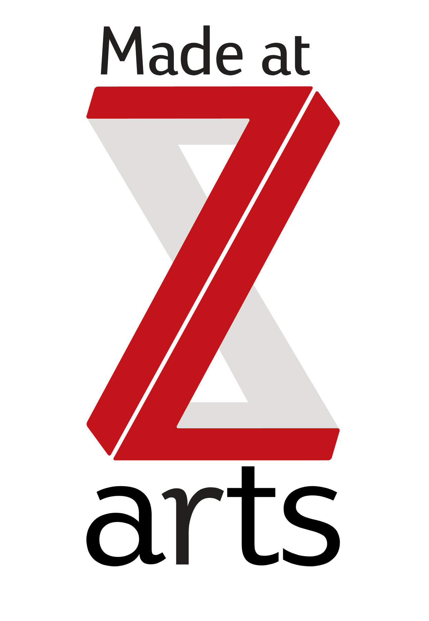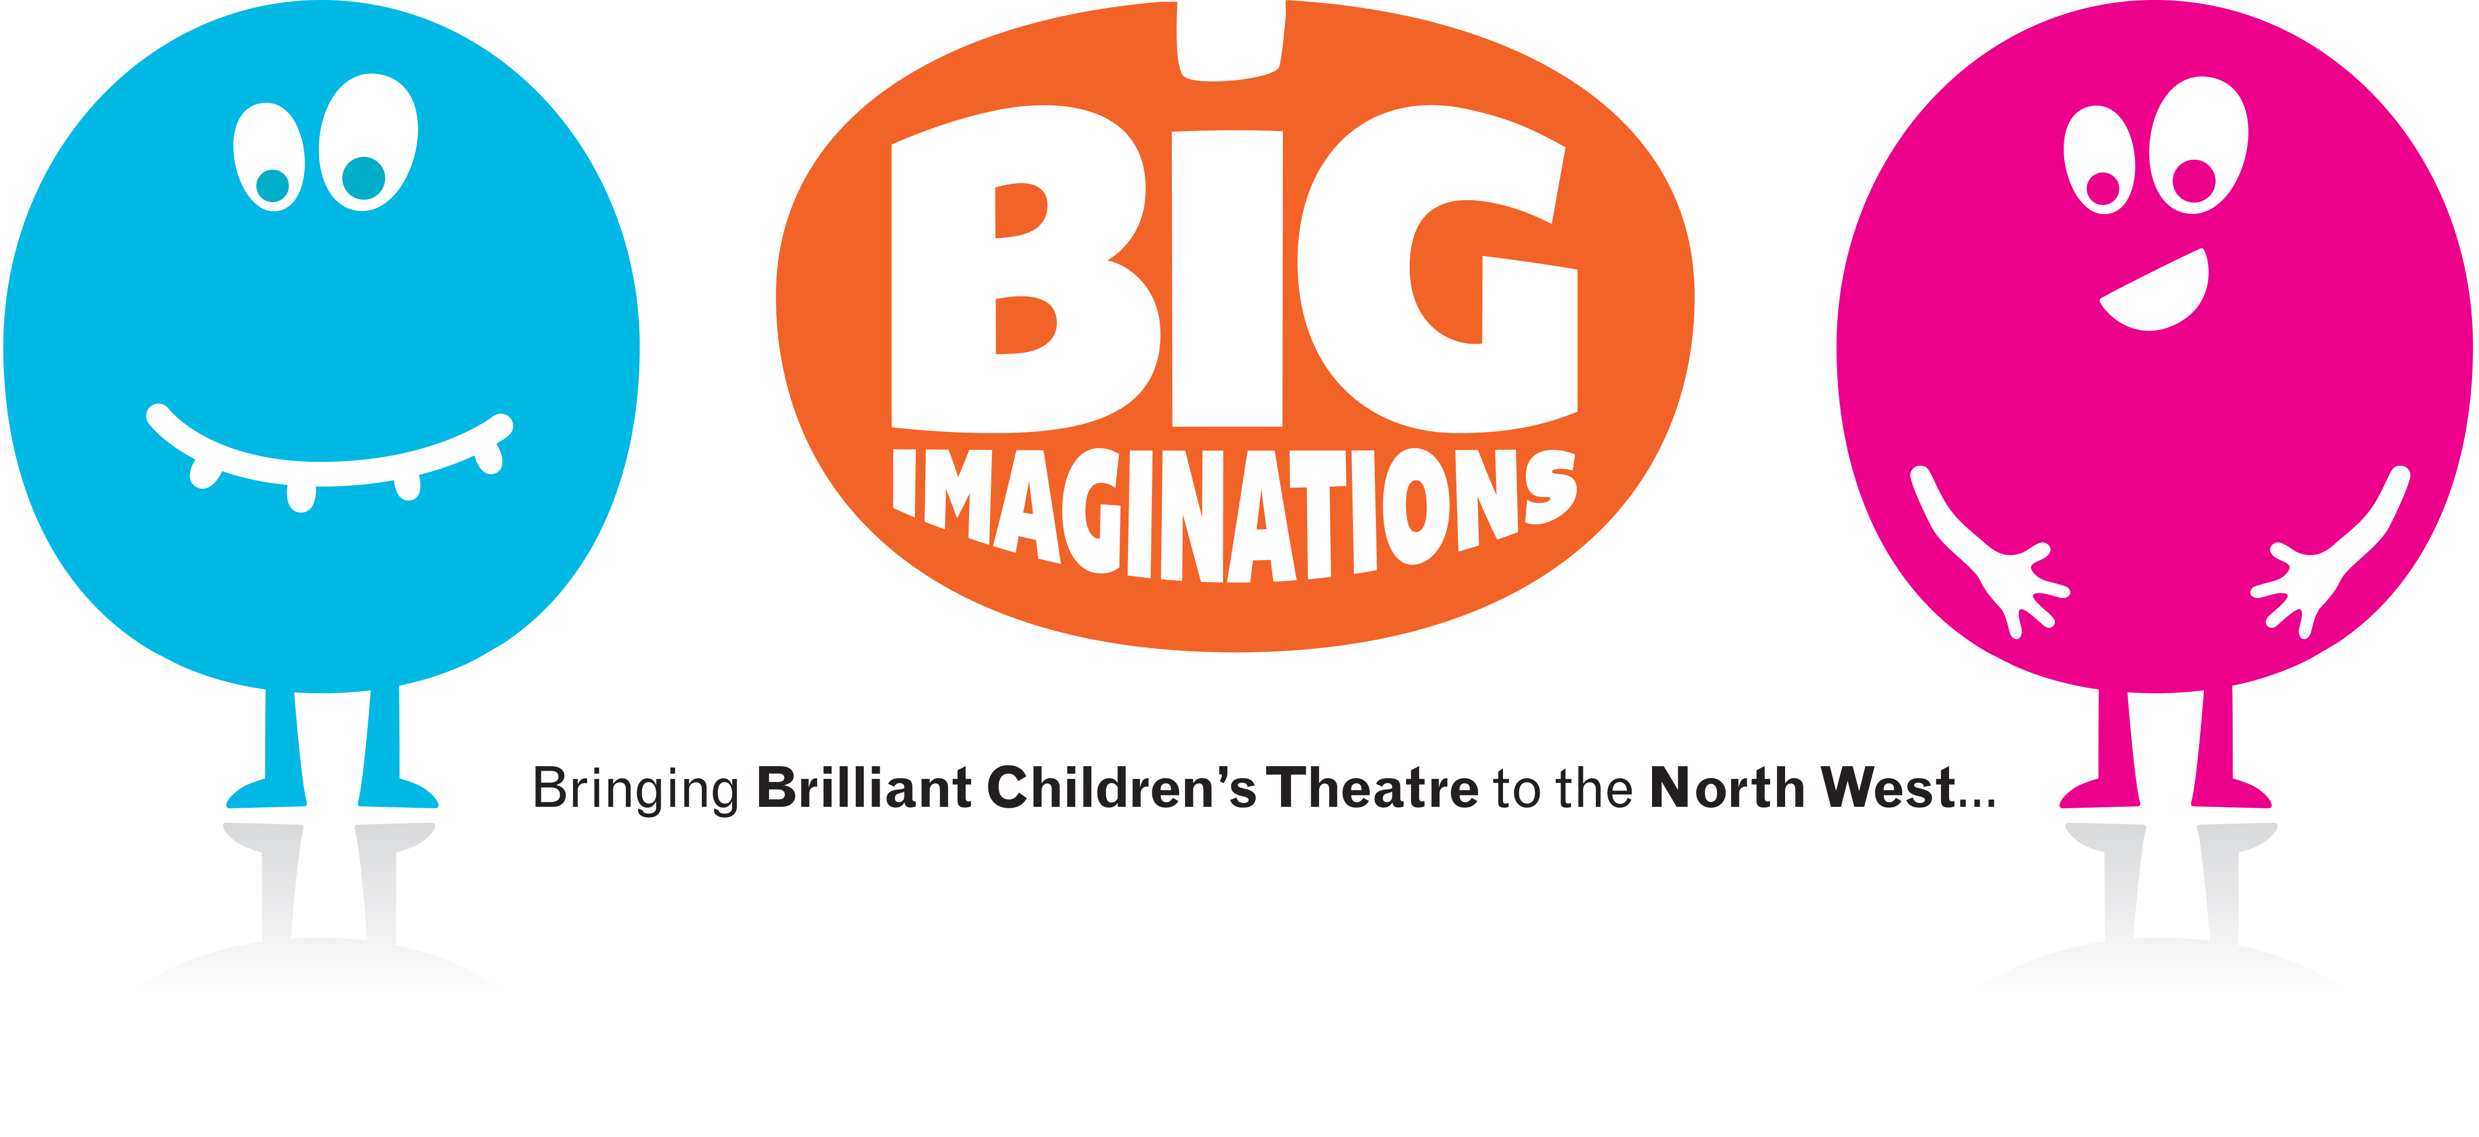****

**Turned On Its Head and Big Imaginations would like to invite you to an individual interview for a multi-sensory, participatory show for children aged 6 months – 4 years.**

Turned On Its Headmakes immersive, participatory theatre which is widely acknowledged to be pushing the boundaries of dance theatre for children with a strong sense of inclusivity at its heart.

Dancers are required to have contemporary and improvisation techniques as well as skills and experience in working with very young audiences (6 months – 4 years). Dancers must have an interest in story, adventure, be flexible in their approach to working and performing and have a great sense of humour. As the performances take place in the North West, dancers must be from the North.

*Sponge* will be Turned On Its Head’s second show following on from the success of *Shiny*.

Co-commissioned by The Spark Arts and produced by Big Imaginations, *Sponge* will open at The Just So Festival in August, a magical festival for families set in the beautiful estate of Rhode Hall, Cheshire before beginning its tour of the North West.

We are looking for dancers for contracts starting in August 2016 and continuing in blocks in Oct, Dec 2016 and May/June 2017.

We are operating to at least ITC/equity minimum, dependent on experience.

**AUDITION INFORMATION**

Monday 21st March 2016, 10.30am – 4.30pm

Z-arts, Manchester

335 Stretford Road

Hulme

M15 5ZA

[0161 226 1912](tel:01612261912)

There will be a contemporary dance class and an opportunity to dance with young children plus individual auditions.

We are looking for 2 dancers with the following qualities:

* Excellent improvisation and contemporary dance skills, including contact improvisation
* Confident observing, interpreting and interacting with audiences
* Comfortable collaborating; friendly and approachable
* Preferred - experience performing shows for young children
* Preferred - experienced in both theatres and non-traditional settings

We value diversity and welcome applications from applicants from all backgrounds. We particularly welcome applications from sections of the community which reflect our audiences in the North West, including BAME. Please note we will not use any personal information relating to your background at any stage of the application process.

To apply, please send the following by email to Zoe Pickering or by post to the address above:

* Your CV
* A recent photo
* Footage of you dancing if possible (by web link if possible)
* A covering letter
* Please state if you have a current DBS check and also supply a name for who we can contact for a reference if you are successfully chosen for an audition.
* Please confirm in your CV if you have the legal right to work in the UK or if you would require a visa to do so

[www.turnedonitshead.org](http://www.turnedonitshead.org)

<http://www.z-arts.org>

<http://www.bigimaginations.co.uk>

**Application Deadline:**

7th March 2016