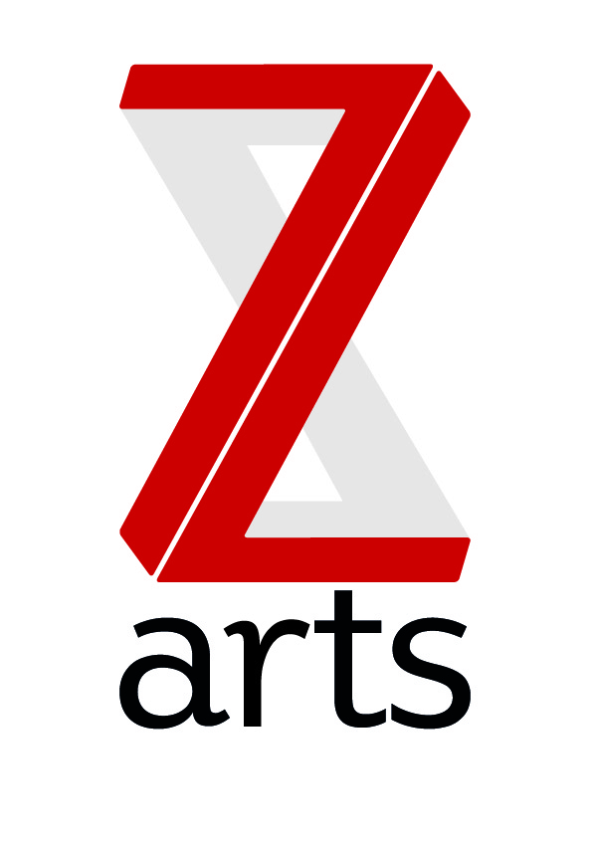

JOB DESCRIPTION

Title: Freelance Arts Educator

RESPONSIBLE TO: Education and Engagement Officer

Manchester’s venue for children and families, Z-arts is dedicated to inspiring creativity in generations of young people by delivering a broad range of visual and performing arts events, performances, exhibitions, activities, workshops and participatory opportunities.

Z-arts is seeking talented arts educators to support the delivery of its highly successful Education and Engagement programmes, which include:

- artist-led activities for children, families, young people and schools
- activity onsite at Z-arts including dance, music, drama and visual arts classes for children 0 – 16yrs and their families
- activity offsite in nurseries, primary and secondary schools that responds to school topic areas and broader cultural themes whilst encouraging and cultivating creative practice in pupils.
- mentoring and support for teachers, including artist -led CPD opportunities, practical resources and networking opportunities.
- The Bright Sparks membership programme for families and schools, offering affordable access across the programme, encouraging long-term engagement and partnership working.

Z-artists: About our pool of freelance arts educators
Our Education and Engagement programmes are delivered by a pool of creative practitioners, Z-artists, who operate across dance, music, digital arts, storytelling, drama, creative writing, and visual arts. Z-artists deliver creative learning experiences that challenge and inspire young people and teachers, encouraging an appreciation and understanding of contemporary creative practice and supporting personal and academic progression.

Arts Educator call out: Cultural Diversity Offer for Schools
We are currently seeking to expand our pool of practitioners, and welcome expressions of interest from arts educators working across the artforms. In particular, we are keen to hear from artists who identify as being part of a minority group (e.g black ethnic minority, minority faith, LGBTQ, deaf or disabled) and who would be interested in playing a key role in developing and delivering our newly expanded ‘Cultural Diversity’ offer. This will build on the success of our Schools Linking partnership with the Ethnic Diversity Team in Stockport County Council and popular Black History Month activities to create a year-round schools offer which celebrates contemporary creative practice whilst supporting learning and dialogue around diversity, equality and identity. Artists applying within this call out will be asked to support the development of this offer, but will also have opportunities to deliver projects across other areas of Z-arts programmes.

Key duties and responsibilities:
- Planning and delivery of arts-based projects for schools, children and young people
- Sourcing materials as appropriate, and keeping track of materials and expenses within the given budget.
- Designing activities appropriate for the given age range and abilities of the group/class.
- Performing duties responsibly and in line with Z-arts Safeguarding policies
- Supporting the evaluation and monitoring of projects and events
- Collaborating with teachers and members of the Z-arts Creative Team to devise projects that respond to the individual needs of each school. These may, for example, include developing skills in a particular discipline, targeted pupil interventions or raising attainment in particular curriculum areas.

Person Specification:
- Have at least 2 years’ experience leading arts projects with children & young people
- Be able to work effectively with teachers and other members of school staff
- Be confident working in a school setting and managing groups of up to 30 children
- Have experience of planning and delivering engaging and inspiring participatory workshops
- Be able to produce high quality artistic outcomes with young people
- Have excellent communication and time management skills
- Be able to work within strict materials budgets
- Have or be willing to complete an enhanced CRB/DBS check
Desirable qualities:
- Arts Award advisor trained/experience of delivering Arts Award
- Identify as being part of a minority group, and an interest in developing creative learning activities that explore diversity.

Fees and Terms:
Fees are calculated on a basis of £25-30 per hour rate for delivery. Additional preparation time may be paid at £10 per hour in negotiation with the Education and Engagement Officer. Z-artists are freelance and self-employed, and are contracted for work within the programme on an adhoc basis. Joining the pool of artists does not guarantee paid work.

How to Apply:
To respond to the Arts Educator call out, send your C.V, covering letter and any supporting material (images, website links, workshop examples), to hannah@z-arts.org Hannah Gaunt, Education and Engagement Officer.
Successful applicants will be invited to an informal interview initially, and then asked to prepare a short taster workshop for children and young people to demonstrate delivery styles and skills.

Deadline:
Applications must be received by 5pm, 1st April 2016.

