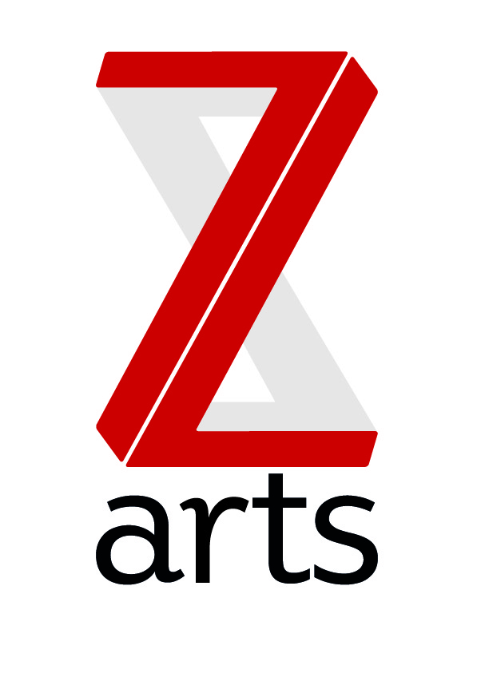

JOB DESCRIPTION

TITLE: Facilities Cleaner (Full or Part time)

RESPONSIBLE TO: House Manager

Dedicated to inspiring creativity, Z-arts delivers a broad range of visual and performing arts events, performances, exhibitions, activities, workshops and participatory opportunities. One of the most versatile cultural buildings in Greater Manchester, Z-arts has an excellent track record in engaging young people of all ages in creative participatory activities and a new ambition to become Manchester’s primary venue for children and families.

PURPOSE: To work as part of the cleaning services team.

HOURS Full time (37.5 hours) preferred but part time (25 hours minimum) is possible. Some weekend and evening shifts will be required as part of the rota

PAY: £9.90 per hour

MAIN AREAS OF RESPONSIBILITY:

• To be responsible for cleaning certain parts of the site as directed by the House Manager or Duty Manager

• To use cleaning materials and PPE as instructed by the House Manager in accordance with Health and Safety guidelines.

• To vacuum all carpeted areas or mop the floors and toilets (occasionally to varnish)

• To sweep all the uncarpeted floors thoroughly after sessions in the afternoon.

• To empty and clean bins and remove waste to designated areas.

• To attend to spillages quickly

• To dust/wash carefully with clean dusters/cloths, desks, seats, ledges, skirting boards and other places where dust lodges.

• To clean toilets, toilet areas and the replenishment of toiletries etc.

• To cleanse hand basins in all toilets.

• To wash off dirty marks on wall tiling and mirrors.

• To clean internal glass, internal and external door glass.

•To set up rooms for use the following morning and to take water jugs to evening classes when required

• To carry out periodic cleaning of all internal surfaces to a height of eleven feet max.

• To periodically clean internal windows at ground level to a height of eleven feet.

• Checking and closing windows, switching off lights after work and locking doors

• Carry out such other duties as may be allocated from time to time.

• Report all defects/hazards immediately to the Duty Manager or Site Technician
This list is not exhaustive and you will be required to undertake any other reasonable requests made by the Duty Manager

General information:
To comply with legislation covering the activities at Z-arts, it is required that all staff undertakes training as directed by their line manager. It is also essential that all staff carry out their duties in a safe manner in accordance with the current Health and Safety at Work legislation.

Person Specification

The successful candidate will be able to demonstrate the following:

- Good spoken English
- Knowledge of commercial cleaning materials
- A basic level of literacy
- Awareness of Health and Safety in the work place
- Good customer service skills

The following attributes would be desirable:

- Working knowledge of commercial cleaning equipment
- First Aid at Work qualification
- Experience of having worked in a large public building

