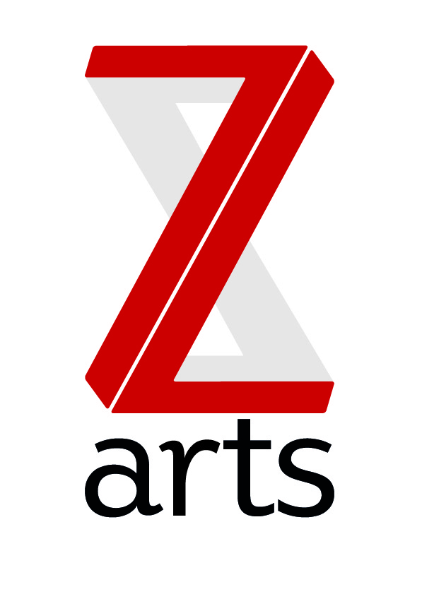

JOB DESCRIPTION

Z-arts is an equal opportunities employer, who is actively seeking to employ people currently under-represented in the creative and cultural sector. This includes young people, ethnic minorities and people with disabilities.

TITLE: Festival Outreach Intern

RESPONSIBLE TO: Children’s Theatre Programme and Big Imaginations Manager

As Manchester’s venue for children and families, Z-arts is dedicated to inspiring creativity in children and young people. Z-arts delivers a broad range of visual and performing arts events, performances, exhibitions, activities, workshops and participatory opportunities. One of the most versatile cultural buildings in Greater Manchester, Z-arts has an excellent track record in engaging young people of all ages in creative participatory activities in the venue, at schools and in community settings.

Z-arts also leads Big imaginations a consortium of venues and programmers across the North West dedicated to bringing brilliant children’s theatre to the region.

This internship will work directly with Big Imaginations venues and identified communities and audiences who may not think that the theatre is for them. Big Imaginations will work with 3 artists who will design workshops and work with venues to find the groups that the workshops will go to.

PURPOSE: To coordinate the outreach programme in the lead up to the Big Imaginations Festival.

HOURS: 7 hour days – 18 days between July and August – 2 days per week / 27 days between Sept-Nov – 3 days per week (paid at £7.50 per hour)

MAIN AREAS OF RESPONSIBILITY:
- To work with 3 artists to create a menu of visual arts, drama and music workshops.
- To help venues build relationships with community groups and liaise with venues and artists to book in workshops.
- To make sure all schedules are up to date and shared.
- To attend workshops and build relationships with audiences.
- Creating risk assessments for activities and liaising with artists to obtain external risk assessments.
- Creating and updating a regular blog post.
- To support community groups to attend Big Imaginations venues.
- Working within the evaluation framework and collating relevant information.
- To support Big Imaginations venues' in house arts workshops.
- To work with the entire staff team to support and deliver Z-arts strategic and creative vision.
- To adhere to all Z-arts policies and procedures.

Person Specification:
- Friendly
- Happy to go into different communities with a welcoming attitude.
- Great communication skills.
- Knowledge and experience of using IT, including the use of Microsoft Office Software.
- Project Management / good organisation skills.
- Strong communication skills, both verbal and written.
- An interest in working in a creative environment.
- Ability to build and sustain good working relationships.
- Ability to exercise initiative and take personal responsibility.
- Ability to work effectively under pressure and deal with conflicting demands.
- Ability to work well in a diverse team and cooperate with others.
- Excellent time keeping skills, conscientious and punctual.
- An understanding of the importance of confidentiality.

To Apply

Please send a copy of your CV and a covering letter detailing why you think you would be suitable for this internship to paul@z-arts.org by Friday 23rd June at 12noon.

Interviews will be on Thursday 29th June.

If you have any questions about the internship please contact zoe@z-arts.org

