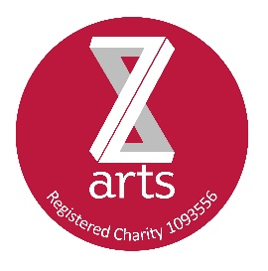
Bar Price List

WINE | 125ml |  | 175ml |  | 250ml |  | Bottle
 | £3.00 |  | £4.00 |  | £5.00 |  | £15.00
CAVA |  |  |  |  | Small Bottle |  | Bottle
 |  |  |  |  | £5.00 |  | £17.50
BOTTLED ALE/CIDER
Budvar/Corona |  |  |  |  | £3.50
Red Stripe |  |  |  |  | £3.50
Erdinger / Tyskie |  |  |  |  | £4.50
Bottled Ales |  |  |  |  | £4.50
Magners |  |  |  |  | £4.50
Wyld Wood |  |  |  |  | £4.50
Flavoured Cider |  |  |  |  | £4.50
Alcohol Free Becks / Erdinger |  |  |  |  | £2.50 / £3.00
Soft Drinks |  |  |  |  | Hot Drinks
Pop Large  Pop Small |  | £1.00  50p |  |  | Latte/cappuccino  Americano/espresso | £2.10  £1.95
Capri Sun |  | 50p |  |  | Tea | £1.80
Juice cartons |  | 85p |  |  | Hot Chocolate | £2.00
Perrier  Volvic  Fruit Juice |  | £1.50  £1.00  £1.50 |  |  | Mocha | £2.20
 |  |  |  |  | ‘Top-up’ tea/coffee | £3.50/£4.50  (as many refills as you want)
 |  |  |  |  | Tea and cake  Coffee and Cake | £3.50  £3.95
Sweet snacks |  |  |  |  | Savoury Snacks
Propercorn |  | £1.25 |  |  | Real Crisps | 95p
Tunnocks |  | £1.00 |  |  | Kids Crisps | Pricemarked
Ellas kitchen | £1.50
Lich Squares |  | £1.50 |  |  | Mini Cheddars | 60p
Nak’d Bars  Cakes  Black Cat Brownie  Ice Creams  Fruit/fruit portion |  | 85p  £2.25  £1.95  £2.00  75p/£1.00 |  |  | Raisins  Nuts | 25p  90p

